Types of ASN
# Source: Chatgpt (GPT‑5 Mini) at [12/15/2025]
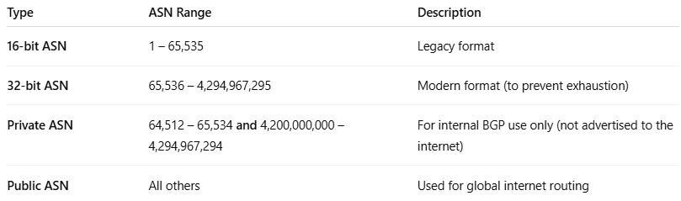

Type | ASN Range | Description
16-bit ASN | 1 – 65,535 | Legacy format
32-bit ASN | 65,536 – 4,294,967,295 | Modern format (to prevent exhaustion)
Private ASN | 64,512 – 65,534 and 4,200,000,000 – 4,294,967,294 | For internal BGP use only (not advertised to the internet)
Public ASN | All others | Used for global internet routing

